

Team  
Prohaktiv  
--

StepRecorder

# Get Started

**Connect via Vpn**

* Copy the below url and type it into address bar to your browser

<https://ijump.hostopia.com/aPsprint/>

* It shows below screen shots and ask for the credentials such as username and password
* 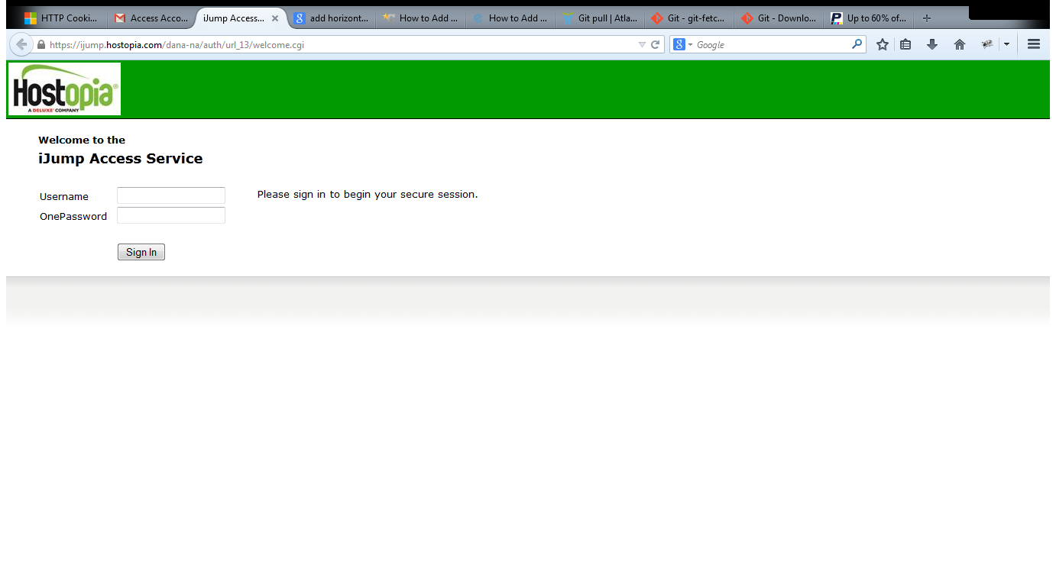
* Provide the username and password and sign in .
* After that you will find below screen and click on start button
* 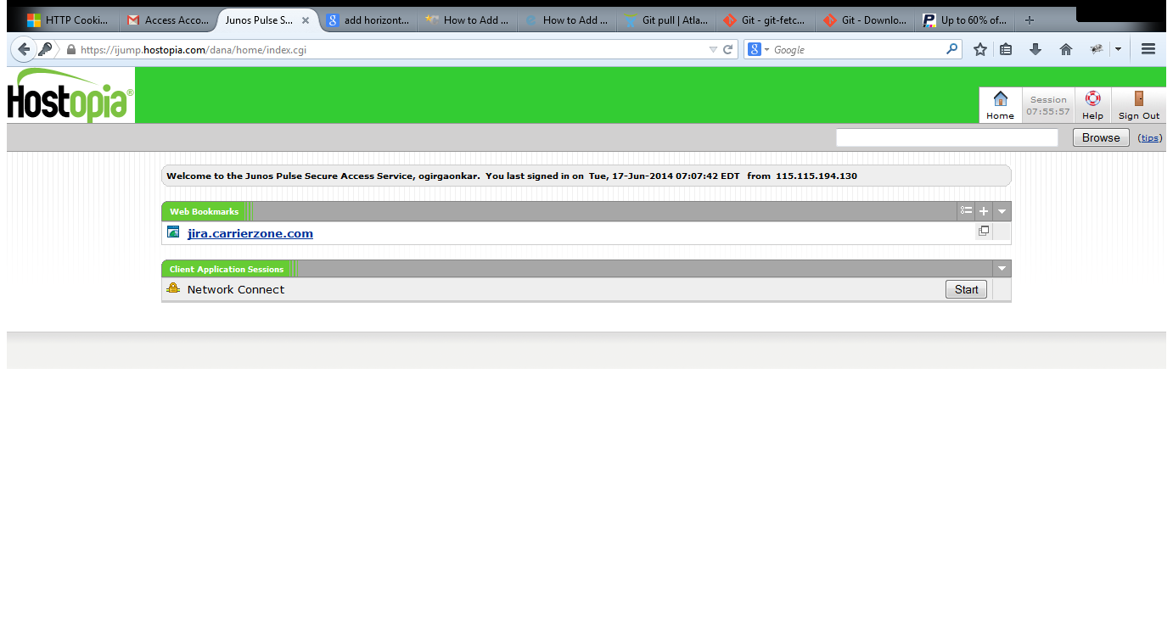
* Keep patience wait for a time
* 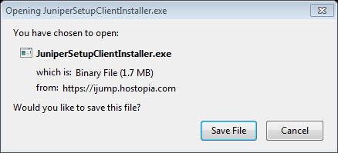
* Save the file and go ahead once the installation is complete , go to start >all programs >juniper networks you will find
* 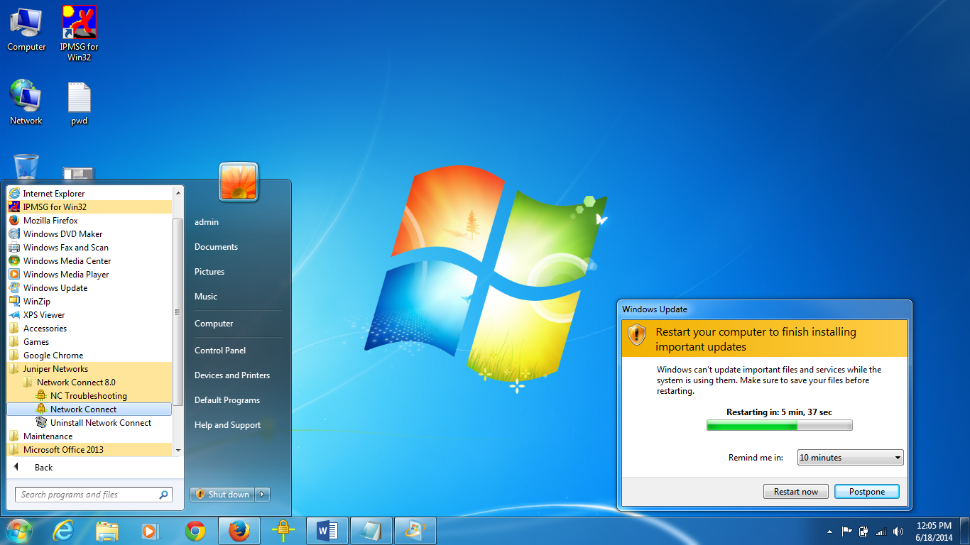
* Click on network connect , then you will come across
* 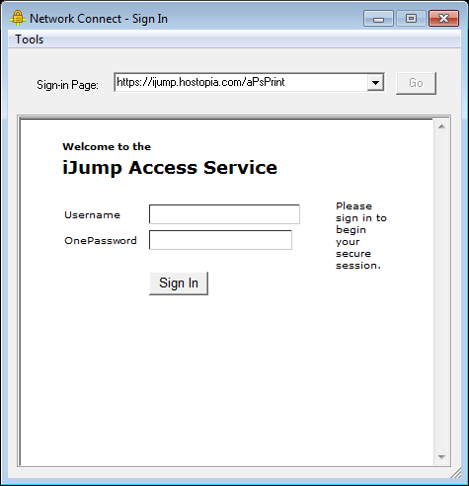
* Provide your credentials and click on sign in
* 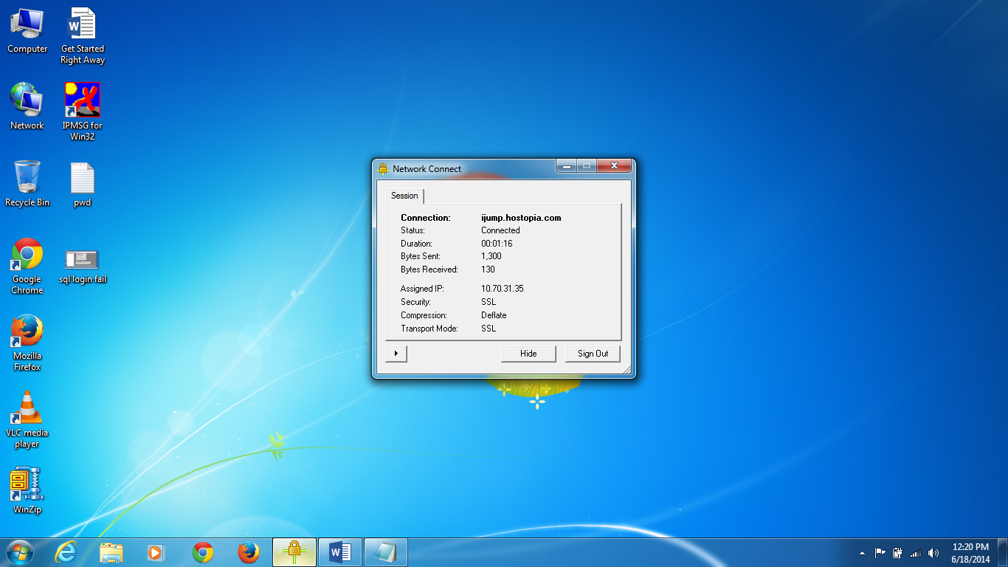
* Once you logged then hide or minimize the above window.

**Remote Desktop Connection**

* Now its time to go with Remote Desktop Connection
* Go to start and find the Remote Desktop Connection, and provide below ip address as mention in the capture screen
* 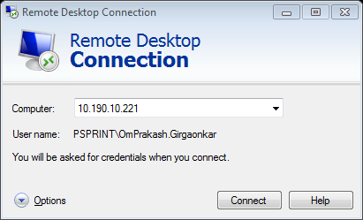
* Click on connect and go ahead
* 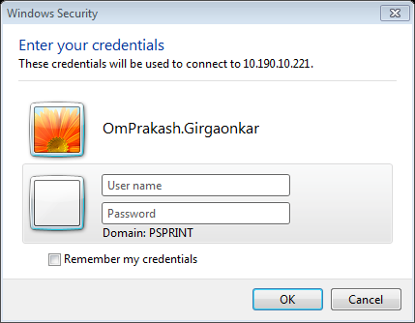
* Choose another account, provide credentials and go ahead
* Once you login successfully you have access to remote machine
* 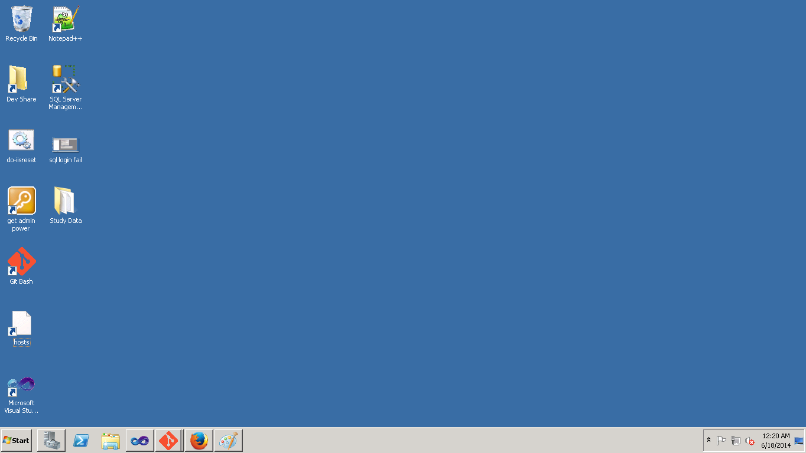

**Get digging into code by using git**

* Firstly map your drive

Press windows +E button then you will move to

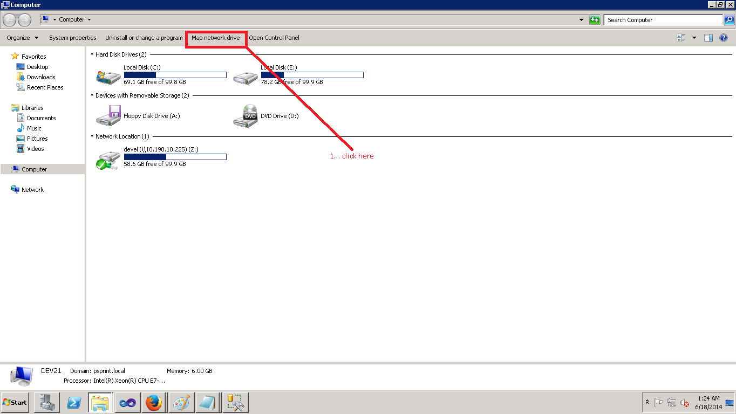

After click on map network drive , you will find below capture screen

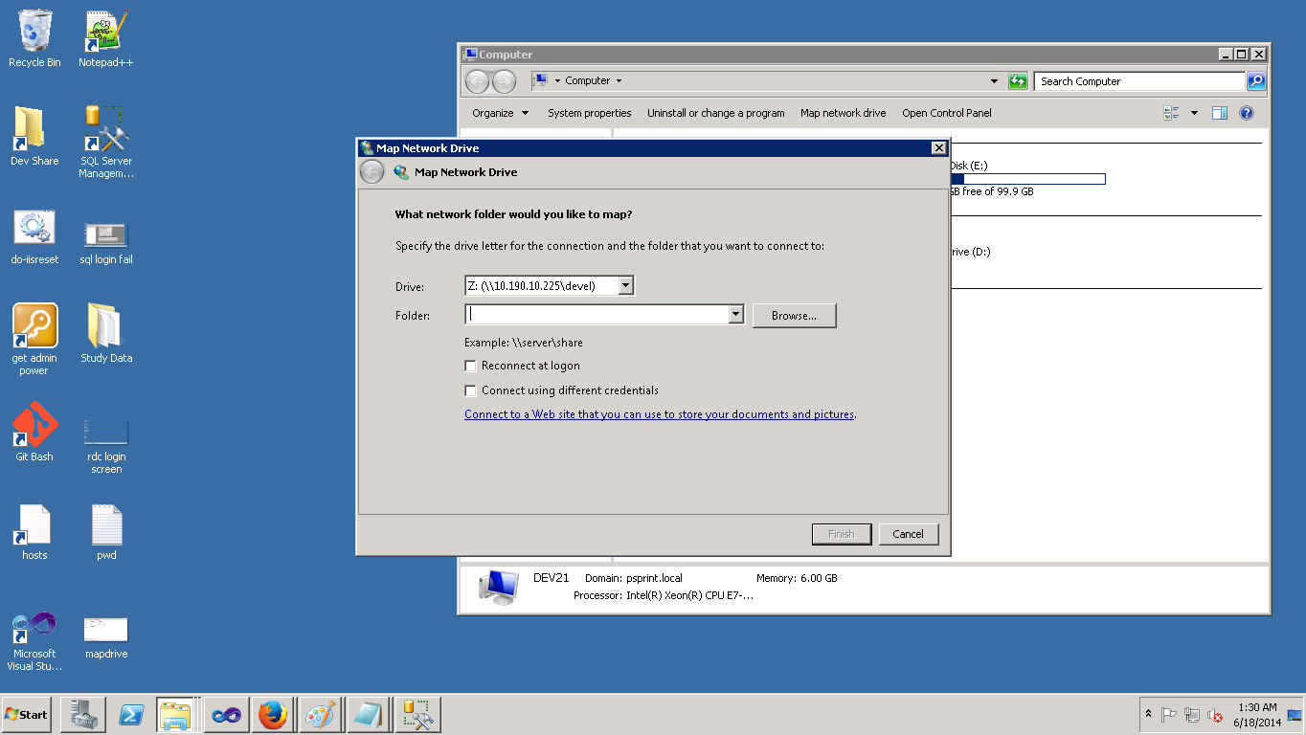

Here we are supposed to give proper inputs

1.Map dive with z into first drop down list 2. Put ip address \\10.190.10.225\devel in second drop down list 3. Select checkbox naming as connect using different account.

Once this done then click on finish

* After click on finish the next window will ask for credentials such as username and password as “ user - psprint\git; pw - PsP2013$” , find the below captured screen

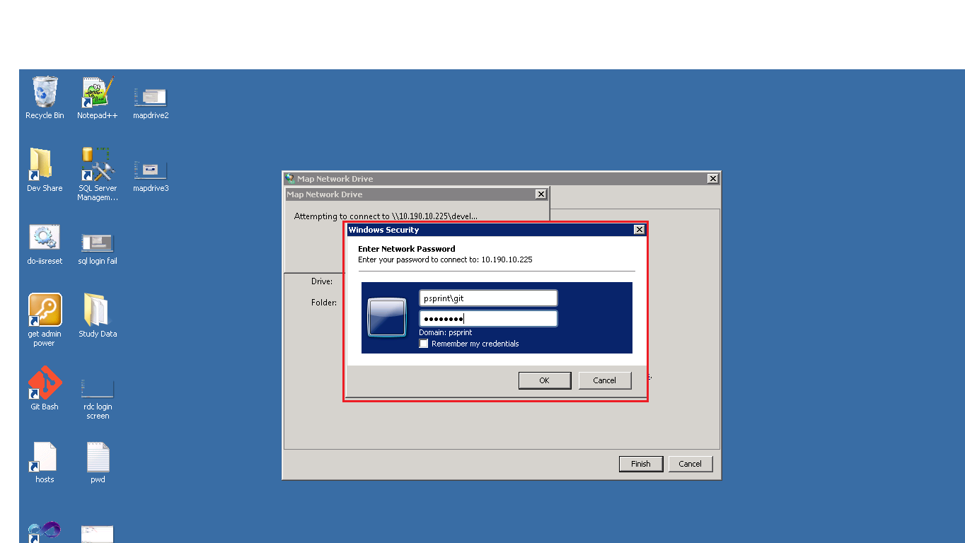

Once this done now you are able to use git repository content to your local repository.

* Go to start then > all programs >git>then click on git bash

Once you click on this you will find the black screen as follows .

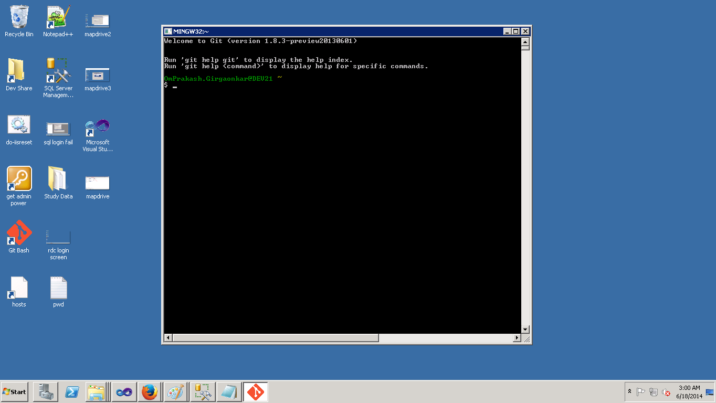

Now here onwards all git commands are needed to fire, for all operations regarding code management from got repository.